BUS RESERVATION APPLICATION

The whole Case Study project will be divided into many modules (35 – 45 modules). All functionality are divided in 3 groups with 3 different micro services and each group will work with one micro service and each participant of JEE Cloud -FLP will work on an individual module from each micro services. . Everyone will share a common database. The architecture and package structure (nomenclature) must be the same for everyone. Once the micro service and individual functionality is realized, it will be integrated in one system and upon successful integration, it will be deployed for project evaluation

**TEAM MEMBERS:**

Manish : Bookings Module

Phalgunendra : Schedule Module

Sai Krupa : User Module

Santosh : Admin Module

**A BRIEF ON BUS Booking Application**

**ABOUT BUSBOOK**

This project presents a review on the software program "Online Bus Ticket Reservation System" as should be used in a bus transportation system, a facility which is used to reserve seats, cancellation of reservation and different types of route enquiries used on securing quick reservations. OBTRS is built for managing and computerizing the traditional database, ticket booking and tracking bus and travel made. It maintains all customer details, bus details, reservation details.

 The software achieved is capable of improving the customer hand and relationship management in ITC operations. It is recommended that despite the present functionality of the designed software, an additional functionality such as the use of E-mail to send tickets and notifications to the customer and an online payment using credit cards/debit cards should be implemented into the system. Furthermore, other operations carried by ITC such as the courier services should also be integrated in order to enhance the system.

**Macro level Operations/offerings:**

1. **User Management** :- Signup, Login or Logout
2. **Booking Management** - Accept Booking details and list all bus details, Search Bus based on route and Date, Bus Ticket booking, , cancellation of tickets, searching bus routes
3. **Schedule Management:** Add schedules, view schedules
4. **Admin Management:** Add buses, View Buses

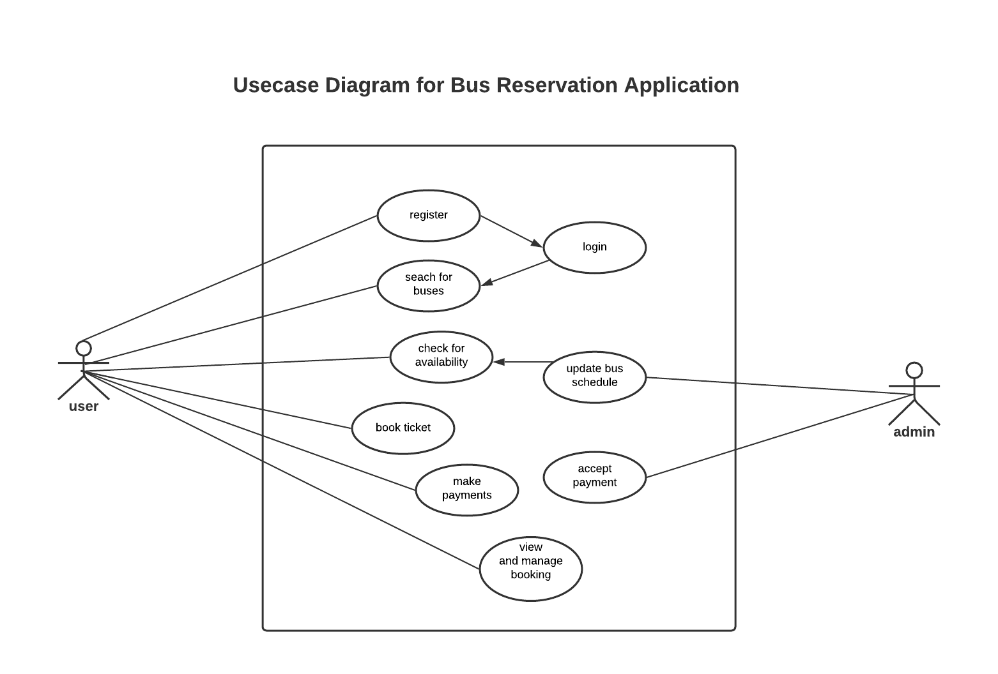

E-R Diagram

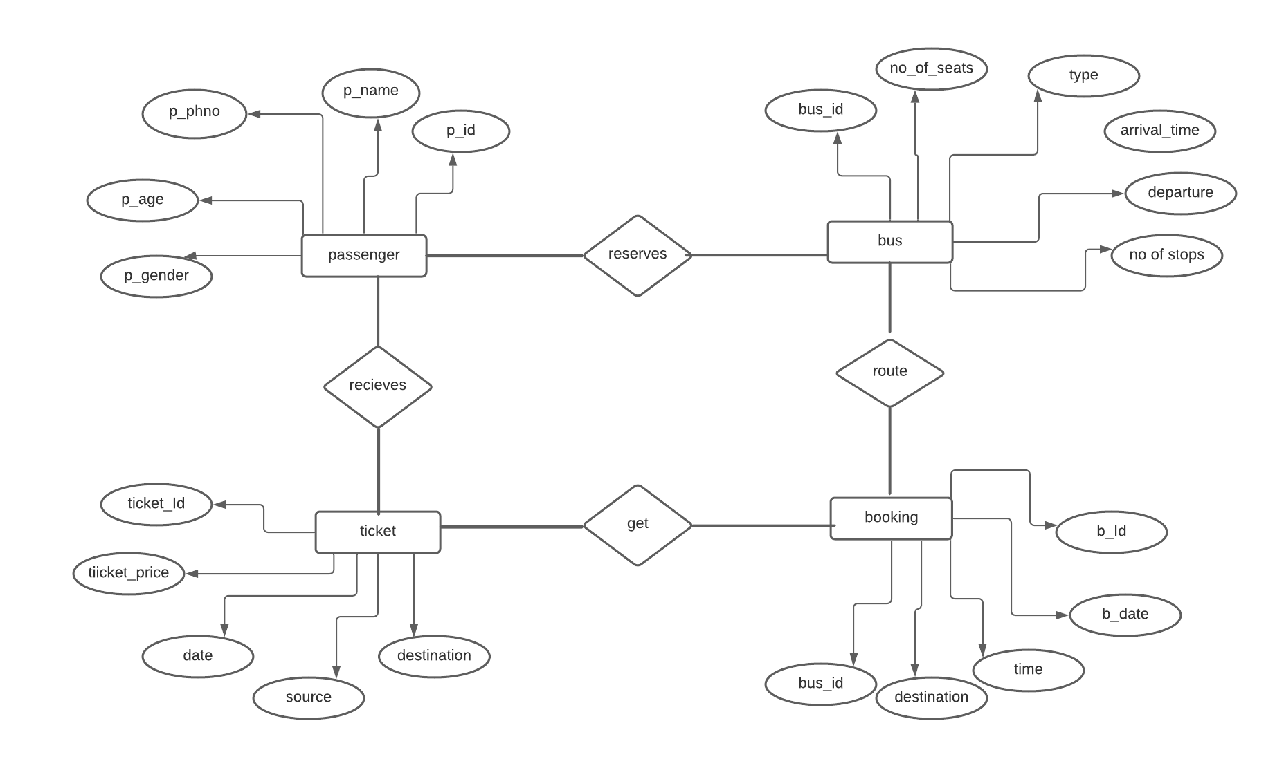

Sequence Diagram - User

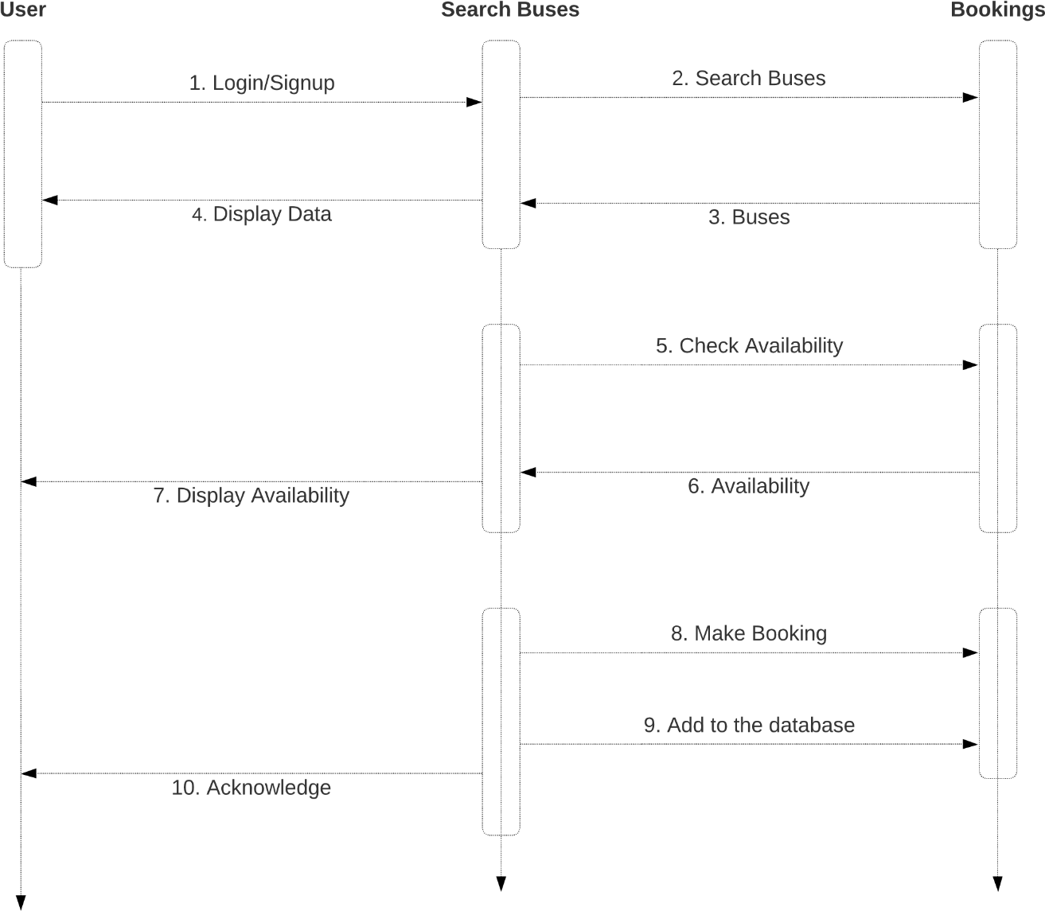

Screenshots:

User login:

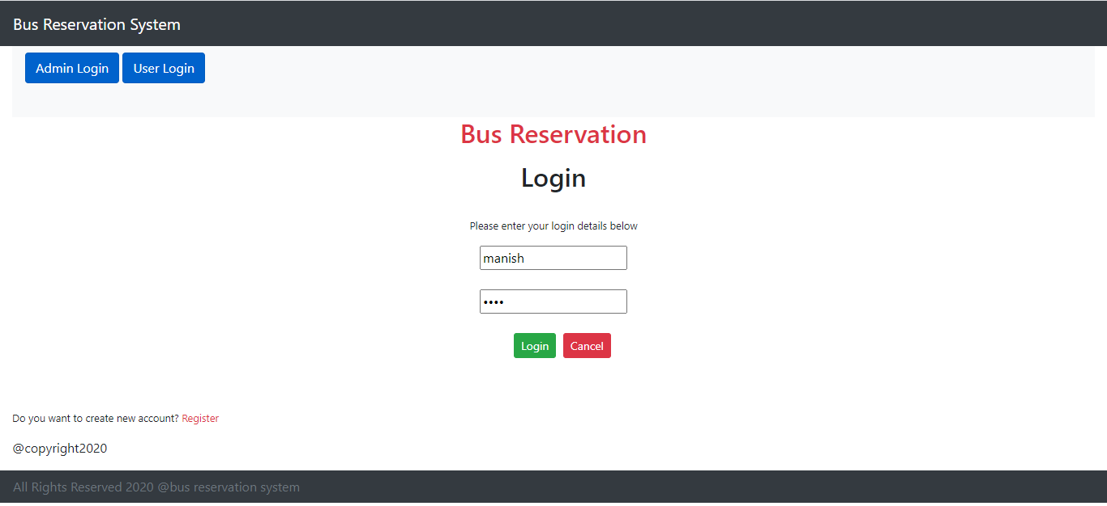

Admin login:

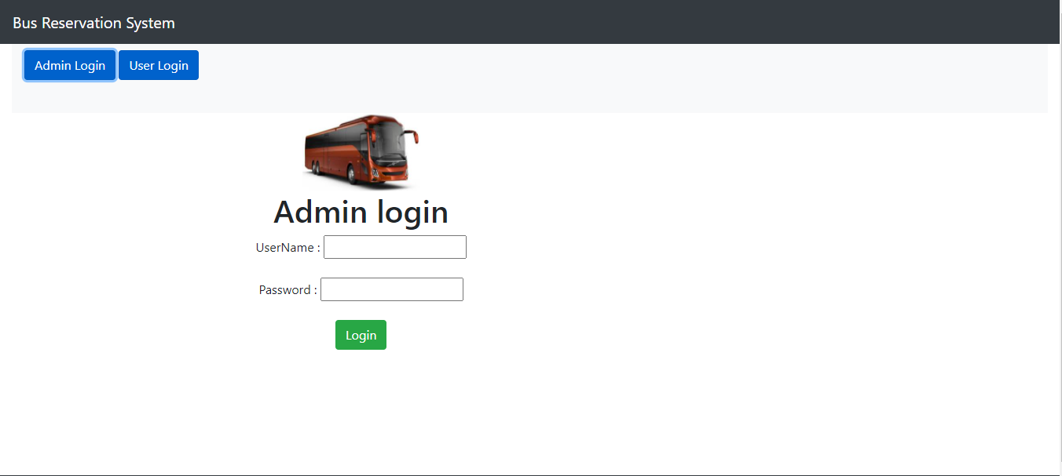

Add Bus:

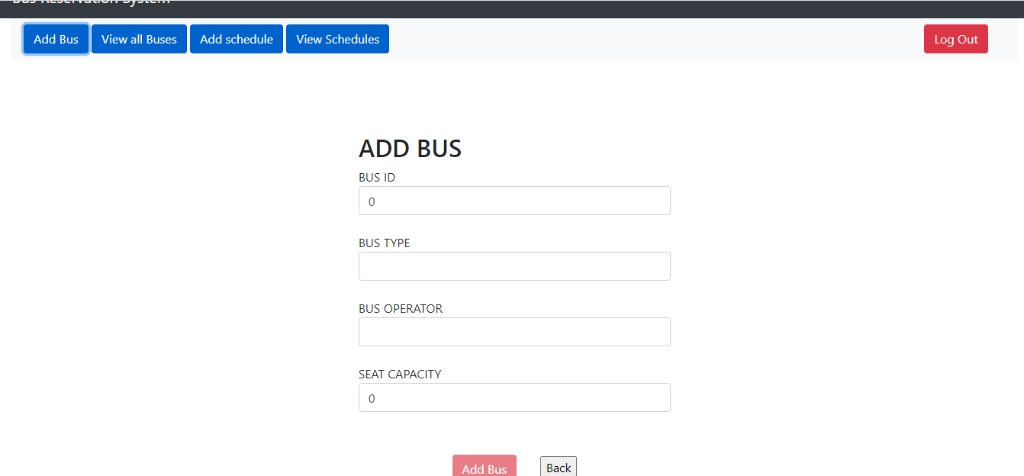

View all Buses:

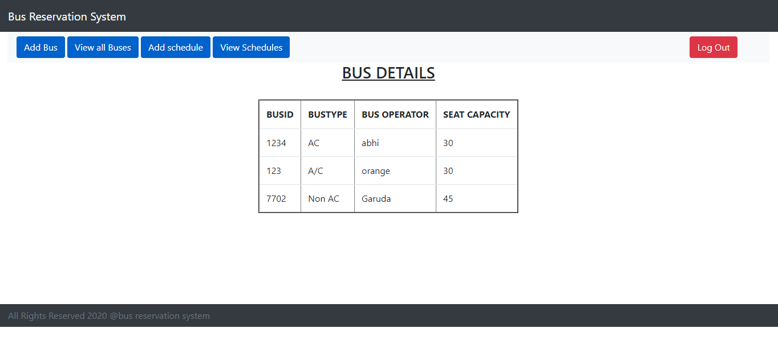

Add Schedule:

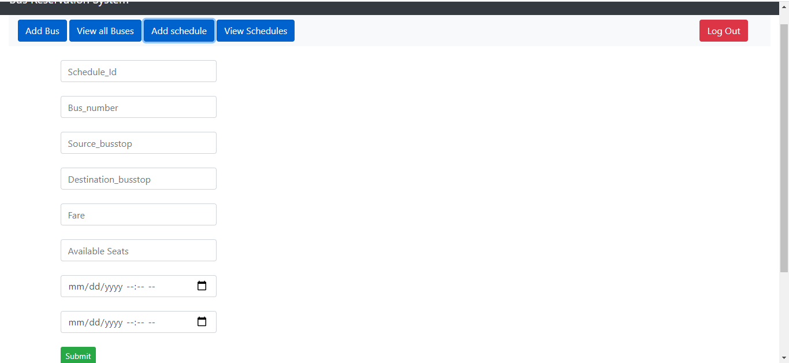

View Schedules:

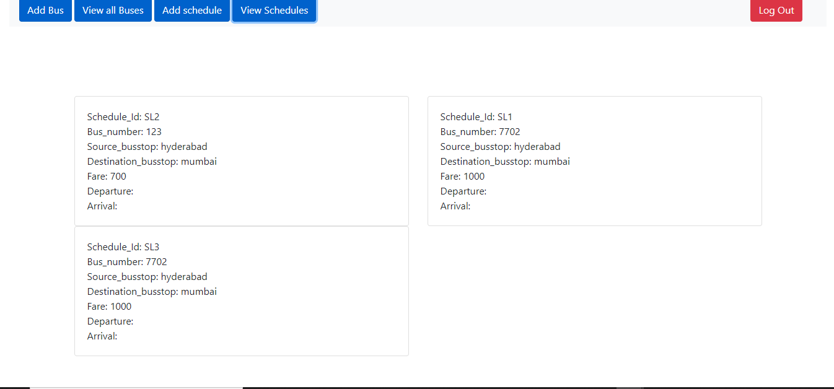

Add Booking:

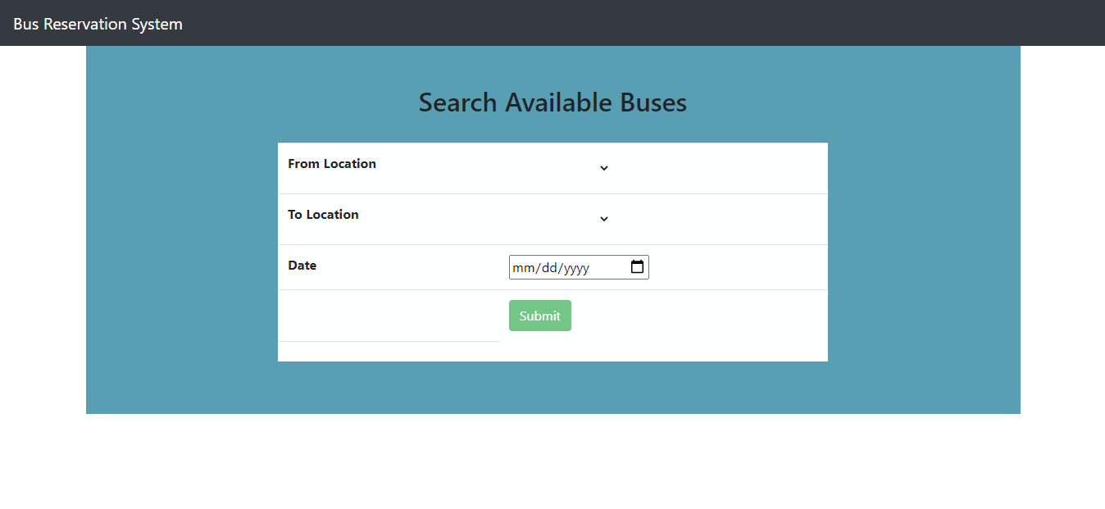

View Bookings:

